Integration

Video 1, Popper 12

Definition
Power Rule for Anti-derivatives
The Indefinite Integral
The Definite Integral

Application Problems
Definition

Integration is a process that recovers the original function from its derivative within the boundary of not knowing the constant term.

Denoted: F(x) = $\int{f(x)\text{dx}}$

“F(x)” is called the “anti-derivative”.

Taking a definite integral is a process that will tell you the area between the curve and the x-axis along a closed segment of the x-axis, [a, b]

Denoted: Area = $\int_{a}^{b}{f(x)\text{dx}}$

Power Rule for Anti-derivatives:

$$\int{x^{n}\text{dx}=\frac{1}{n+1}} x^{n+1}+C$$

“C” is the constant of integration and may be zero or any other number.

Example 1:

f(x) = $x^{3}$ Find: $\int{x^{3}}\text{dx}$

n = 3 so n + 1 = 4

$\int{x^{3}}\text{dx}=\frac{1}{4}x^{4}+C$

Here’s why we need the C:

If

That’s the SAME derivative! So to cover any added on constant we put “+ C” on when we’re done with the integration.

Example 2: How to handle coefficients:

f(x) = $5x^{7}$ Find: $\int{5x^{7}\text{dx}}$ $\int{x^{n}\text{dx}=\frac{1}{n+1}} x^{n+1}+C$

Example 3: How to handle polynomials

$\int{3x^{2}+2x+1 \text{dx}}$ $\int{x^{n}\text{dx}=\frac{1}{n+1}} x^{n+1}+C$

Popper 12, Question 1

Example 4: How to handle exponential functions

$$\int{3^{x}}\text{dx}$$

$$\int{\text{ln}5(5^{x})\text{dx}}$$

Example 5: Suppose you get one more fact: the y-intercept of the anti-derivative

$\int{5x^{2}}+x+3 \text{dx}$ and F(0) = 5. This lets you eliminate the “C”!

Example 6:

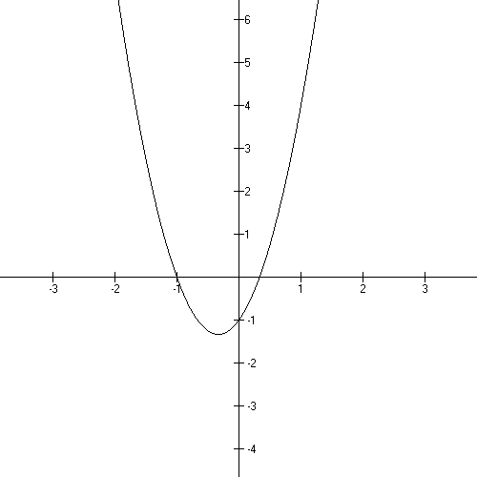
Now, let’s look at $f(x)=3x^{2}+2x−1$

It’s derivative is $f'(x)=6x+2$,
The derivative gives you the slopes of
the tangent lines as you move from x to x.

It’s anti-derivative is
F(x) = $x^{3}+x^{2}−x+C$

$f(x)=3x^{2}+2x−1$ Work it out:

Suppose now I tell you that F(0) = − 2

Then it’s anti-derivative is
$F(x)=x^{3}+x^{2}−x−2$

The anti-derivative gives you the AREA under the curve from a specific x to another specific x. If you want to know the area under the curve from x = 1 to x = 3, you subtract
F(3) − F(1).

If you want to give this instruction to someone, you tell them:

$\int_{1}^{3}{f(x) \text{dx}}$

This collection of symbols means ‘find the area under the curve from x = 1 to x = 3”.
This form of integration is called “the Definite Integral” The form without the limits is the “Indefinite Integral”.

Color in the area and let's calculate the area
under the curve from 1 to 3.
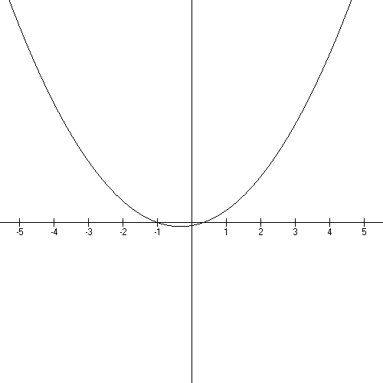

$$F(x)=x^{3}+x^{2}−x−2$$

(F(1) =

F(3) =

Area of the shape is:

Example 7: Find the area under this curve from 0 to 3.
Shortcut: You may ignore the “+ C” if you have a definite integral!

$$\int_{0}^{3}{4x^{3}−3x^{2}+1 \text{dx}}$$

Now let’s take a minute to see where we are:

When I say “tell me everything about this function”

You need to provide:

Domain
Range
Intercepts
Asymptotes
Graph
A brief discussion on continuity
A listing of important limits
Its derivative and what it tells you
Its anti-derivative and what it tells you

You can no longer think about f(x) as being some function Outstanding in it’s Field…it is part of a complex system of functions now. It has an anti-derivative that is a function and a derivative that is a function.

For example:

It’s derivative is (tell me everything!)

And it’s anti-derivative is (another candidate for TME!)

Each of these is a function in its own right!

Popper 12, Question 2

Let’s do one up totally: Example 8:

f(x) =

Domain $(−∞,∞)$
Range: $[−\text{16},∞)$ do Complete the Square to get $(x−2)^{2}−\text{16}$
Intercepts: x = −2, x = 6, y = −12
no asymptotes or holes

The graph is everywhere continuous because it is a polynomial.
Decreasing: $(−∞, 2)$
Increasing: $(2, ∞)$

f(x) =

Derivative: $f'(x)=2x−4$ gives you a turn around point at 2
Anti-derivative: F(x) = $\frac{1}{3}x^{3}−2x^{2}−\text{12}x+C$

Area under the curve from −1 to 2:

$\int_{−1}^{2}{f(x) \text{dx}}$= F(2) − F(−1) = $(\frac{8}{3}−8−\text{24}+C)−(−\frac{1}{3}−2+\text{12}+C)$= $−\text{21}\frac{1}{8}$

What on earth has gone wrong? Area is never negative!
Let’s look at the graph:

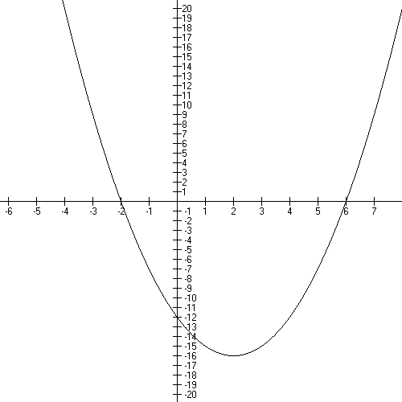

Look: the area I’m trying to calculate is BELOW the x-axis. This means it has been reflected about the x-axis and all the y values I’m using a negative numbers. If ever this happens you need to multiply by −1 to flip the area to the correct side of the x axis for calculation….so our area is 21.125 units squared once we fix the flip.

Example 9:

$\int_{1}^{4}{2x−4 \text{dx}}$

Find the area under the curve from x = 1 to x = 4 for the function given.

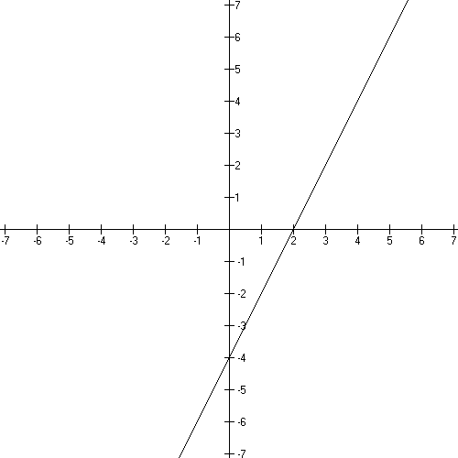

In looking at the graph you should notice that the area from x = 1 to x = 2 is BELOW the x axis so we’ll “subtract” that and then add the area from x = 2 to x = 4.

$$\int_{1}^{4}{2x−4 \text{dx}}=−\int_{1}^{2}{2x−4} \text{dx}+\int_{2}^{4}{2x−4 \text{dx}=−[F(2)−F(1)]+[F(4)−F(2)}]\text{.}$$

F(x) = $x^{2}−4x+C$

So now let’s calculate the area.

Now let’s check it with triangles:

Example 10:

Given: $f(x)=x^{5}+2x^{3}+9$

Find it’s anti-derivative and it’s derivative.

Popper 12, Question 3

Example 11:

Given this anti-derivative, find the formula for the original function and find the area of between the graph of the original function from x = 3 to x = 5.

$$F(x)=x^{3}−\frac{5}{2}x^{2}−2x+9$$

First let’s get the original function: f(x)

Then let’s translate the instructions to symbols and check the graph of the original function:

f(x) looks like this:

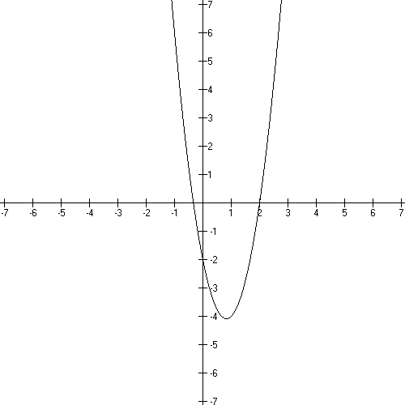

Now let’s do the integration from 3 to 5….Notice: the shape is NOT a triangle, the left hand side is curved…yet we can find the area without a general formula.

Example 12:

$$f(x)=(\text{ln}4)(4^{x})$$

Find the anti-derivative and the derivative of this function.

Popper 12, Question 4

Example 13: New facts:

Derivatives of graphs with discontinuities are inherently more difficult to integrate.
Here’s a little surprise:

$$\int{\frac{1}{x} \text{dx}=\text{ln}\left|x\right|}+C$$

here’s 1/x: here’s ln(x)

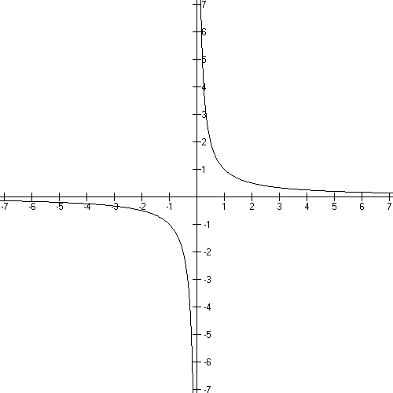

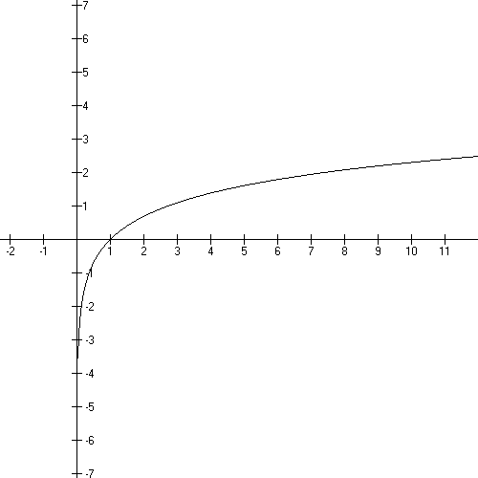

So if you want the area under the curve of 1/x from x = −1 to x = 1, you have to take a limit of your integral…which we won’t do in this class. Just be aware that you can take limits of integrals and finding area across a discontinuity like an asymptote is vastly different than finding areas in places where the graph is continuous. We’ll stick to the continuous parts.

For example: find the area under the curve from x = 1 to x = 3 for 1/x.

ln (3) − ln(1) ≈ 1.0986 − 0 sq. units.

Popper 12, Question 5

Now back to the Big Picture:

Example 14:

$f(x)=4x^{3}+\text{12}x^{2}+6x−4$ a good enough starting point

$$F(x)=x^{4}+4x^{3}+3x^{2}−4x−4=(x^{2}−1)(x+2)^{2}$$

$$f'(x)=\text{12}x^{2}+\text{24}x+6$$

And that’s all nice, but why stop there?

one more integration up is
$$F^{2}(x)=\frac{1}{5}x^{5}+x^{4}+x^{3}−2x^{2}−4x+C$$

and several more derivatives down is:

$\begin{aligned}f\text{''}(x)=\text{24}x+\text{24} \\ \\ f\text{'''}(x)=\text{24} \\ \\ f\text{''''}(x)=0\end{aligned}$

There is an end point to the derivatives but you can keep on doing integrals all the way up to very big exponents.

These functions are related in a couple of senses. In a math sense, it’s a chain of functions related to the initial number 0. If you keep on telling the person doing the work the value of each successive “C”, you can keep on building polynomials forever.

In a teaching sense, let’s look at how we teach math:

First we teach numbers,
then lines and parabolas in two separate chapters!

and along with lines, graphing, zeros, the area of polygons and how to solve for graph points (3x + 12 = 5), SFX is asking ( ___, 5) on 3x + 12, fill in the blank)
Often the connection to graphing isn’t explicit or gets lost but it SHOULD be there.

in algebra two, there’s graphing polynomials and finding graph points of these:

($x^{2}+5x+4=0, \text{SFX})$

and now we’re finding that the zeros of one function are the turn around points of it’s anti-derivative and help define where the function is increasing and decreasing.

Let’s look at some graphs for these functions and draw in these connections.

$$\begin{aligned} \\ f\text{''''}(x)=0 \\ \\ f\text{'''}(x)=\text{24} \\ \\ f\text{''}(x)=\text{24}x+\text{24} \\ \end{aligned}$$

y = 0 is the x axis, which is the Number Line. This is where all the action is in the primary grades. Learning to navigate the Number line is a big deal there.

−1 x 3 means go from 3 to the other side of zero to −3. 9 − 2…start at 9 go 2 to the left to end up at 7. ¾ of 2 means go from 2 to 1.5. Problems like these.

f’’’(x) = y = 24

is working with a specific number and it is 24 steps above the number line. It has points with 2 coordinates: (x, 24).

In particular, there is NO y coordinate that is zero…this means that the anti-derivative has NO turn around points.

The anti-derivative of y = 24 is y = 24x + C.

I would have to tell you that the point (0, 24) is on the anti-derivative of y = 24 so you can fill in the “C”

Now we have y = 24x + 24

Now we’ve got slope; the tangent line IS the function line.
The slope of the tangent line is positive – this is an increasing function. The always positive derivative of this function tells you that. Notice that the number of tic marks and which one is capitalized is seeming fairly arbitrary – that’s because we really start each problem from a different point – one problem might start with a linear function and another with a cubic…the starting point is “f (x)” and it varies!

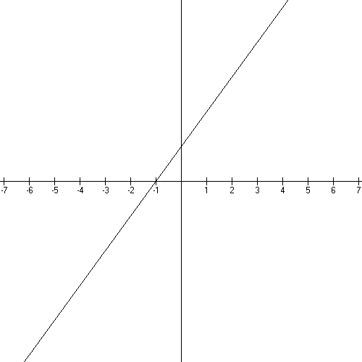
This is an increasing function with no turn around points…as predicted by it’s derivative being always positive and having no x-intercept.

Note that there’s a zero, or x-axis intercept at x = −1. This tells us there’s a turn around point on the anti-derivative at x = −1.

The anti-derivative will be decreasing everywhere its derivative has negative y-values and increasing everywhere its derivative has positive y-values. We can check this by noting that the next function will be decreasing on the left of −1 and increasing on the right. This is another property of derivatives! A derivative will tell you where it’s anti-derivative is increasing and decreasing. Let’s check this.

The anti-derivative of y = 24x + 24 is a quadratic.
I’ll tell you that it’s y-intercept is 6.

After we take the anti-derivative and replace “C”, we have

$$f'(x)=\text{12}x^{2}+\text{24}x+6$$

From the derivative above we know that this graph is decreasing on $(−∞,−1)$
and increasing on $(−1,∞)$. And the TAP is right where we predicted it would be at −1.

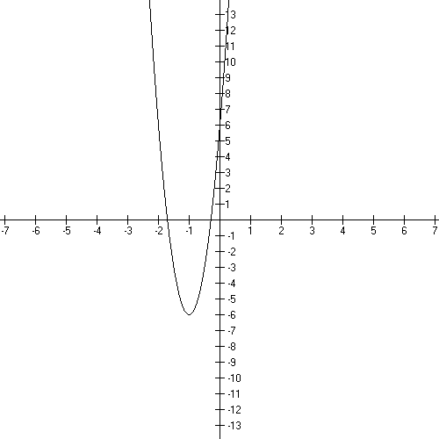

Use the quadratic formula to find that the zero’s are at

x = $−1±0\text{.}5\sqrt{2}≈−\text{.}\text{29} \text{and} −1\text{.}\text{71}$.

Note that there will be two turn around points on the anti-derivative to this quadratic because we have 2 zeros on it’s derivative.

Let’s look at the values for y. The y-values are positive from and negative from . This tells us that the anti-derivative will be increasing on the intervals where it’s derivative is positive and decreasing where it’s derivative is negative. Look at the graph of the anti-derivative below. Derivatives give you a WHOLE LOT of information about their anti-derivatives.

Note: the y-intercept of the anti-derivative to $f'(x)=\text{12}x^{2}+\text{24}x+6$ is −4.
I need to tell you this at each step.

Let’s take the anti-derivative and substitute for “C”.

So now I’ve got: $f(x)=4x^{3}+\text{12}x^{2}+6x−4$

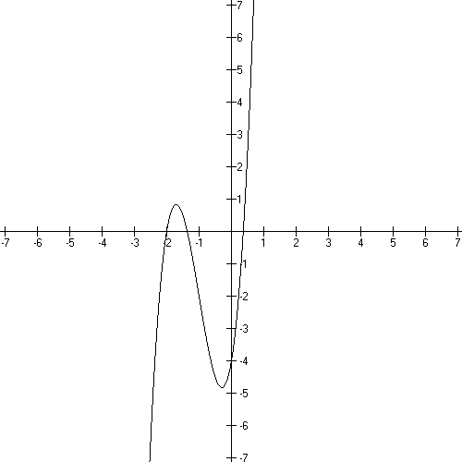
Let’s look at the turnarounds and increasing/decreasing:

We predicted:

x = $−1±0\text{.}5\sqrt{2}≈−\text{.}\text{29} \text{and} −1\text{.}\text{71}$.
To be the TAPs…does that seem reasonable?

This graph is
Increasing on and
decreasing on $(−1\text{.}\text{71},−\text{.}\text{29})$.
as predicted.

Let’s go back and look at those y-values again…

Note: we’ve learned in the Basics section that the end behavior for this polynomial is $↓↑$ (positive, odd) and that the domain and range are all Real numbers.
The y-intercept is −4. There are no asymptotes. It’s continuous everywhere because it’s a polynomial.

Note that this predicts three turn-arounds for its anti-derivative: one at −2, one at −1.71ish, and one at .3ish. And includes increasing/decreasing information as well.

And I’ll tell you that the y-intercept for the anti-derivative is −4.

The next anti-derivative is [for $f(x)=4x^{3}+\text{12}x^{2}+6x−4$]

$$F(x)=x^{4}+4x^{3}+3x^{2}−4x−4=(x^{2}−1)(x+2)^{2}$$

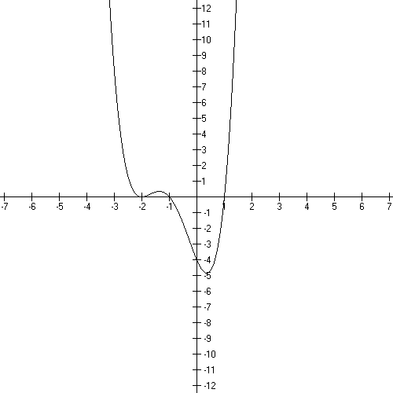

The shape is totally as predicted. The turn around points are −2, −1.7ish and .3ish.

Let’s define increasing and decreasing for this graph and then check out the y values for it’s derivative on the preceding page.

The next y-intercept is 6.
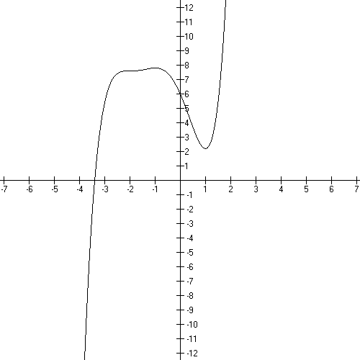

Let’s work with $F(x)=x^{4}+4x^{3}+3x^{2}−4x−4=(x^{2}−1)(x+2)^{2}$to get this one:

Here’s the graph.

Let’s check out the turn arounds and the
increasing decreasing information.

We could just keep on going, but let’s stop and summarize where we are.

Now in the example, we started with 0 and worked our way up to a fifth degree polynomial by having someone else define the y-intercept of the next function.

Let’s look at the list again:
$$\begin{aligned} \\ f\text{''''}(x)=0 \\ \\ f\text{'''}(x)=\text{24} \\ \\ f\text{''}(x)=\text{24}x+\text{24} \\ \end{aligned}$$
$$f'(x)=\text{12}x^{2}+\text{24}x+6$$

$$f(x)=4x^{3}+\text{12}x^{2}+6x−4$$

$$F(x)=x^{4}+4x^{3}+3x^{2}−4x−4=(x^{2}−1)(x+2)^{2}$$

All of these are related to one another by taking a derivative.
It’s just amazing that this structure exists and is accessible to high school students taking Calculus in high school!

Popper 12, Question 6

Application problems:

*
A company manufactures mountain bikes. The research department produced the following marginal* cost function:

In business “marginal” means instantaneous rate of change!
Now C’(x) is in dollars and x is the number of bikes produced per month. Compute the increase in cost going from a production level of 300 bikes per month to 900 bikes per month.

Set up the definite integral and evaluate.

Popper 12, Question 7

*
Another business concept is “useful life” of an asset. Generally when the marginal Cost is equal to the marginal income the useful life is over. 906

An amusement company maintains records for each video game it installs in an arcade. C (t) and R (t) are the total accumulated costs and revenues in thousands of dollars over t years of use. If the research department calculates that

Find the useful life of the game to the nearest year and find the total profit during the useful life of the game.

Popper 12, Question 8

*Average value of a function:

To find the average of a function just multiply the definite integral over the interval [a, b] by the reciprocal of the difference of the limits of integration. 909

The revenue function for a soft drink manufacturer is given by

Find the average revenue over the interval [1, 3].

Popper 12, Question 9

Popper 12, Question 10

